**Sistem expert care alege pentru un utilizator cel mai potrivit campion din overwatch cu care acesta sa joace, in functie de personalitatea sa**

Proiect realizat de Echipa 2 formata din:

Dumitrescu Florin,

Mandea Alexandru-Constantin

Cuprinsul:

Pagina 3:Capitolul de introducere

Pagina 4:Instructiuni pentru consola

Pagina 9:Cazuri generale

Pagina 18:Explicarea etapelor,scop,reguli,intrebari

Pagina 26:Cerinte individuale

Introducere

Acest proiect a fost ales de catre noi deoarece ni s-a parut o tema foarte interesanta pentru un joc video care a devenit foarte popular in ultimele luni,fiind jucat si in campionate international oficiale.

Acest sistem expert este folosit pentru a gasi eroul potrivit pentru un jucator in functie de personalitatea jucatorului si de anumite preferinte personale.

Utilizatorii acestui sistem expert ar fi persoanele care vor sa inceapa a se juca Overwatch si vor sa aleaga un character care li se potriveste din punct de vedere al personalitatii.

Instructiuni pentru consola

Instructiunile folosite pentru consola sunt:

-pornire.Instructiune folosita pentru a reseta toate faptele create anterior si de a intra in meniu,pentru a alege una dintre optiunile valabile



-incarca.Instructiune folosita pentru a incarca fisierul care are toate datele(scop,reguli,intrebari )necesare pentru a rula sistemul expert.





-consulta. Instructiune folosita pentru afisa si raspunde la intrebarile necesare cu valorile potrivite pentru a ajunge la solutia care se potriveste acelor valori

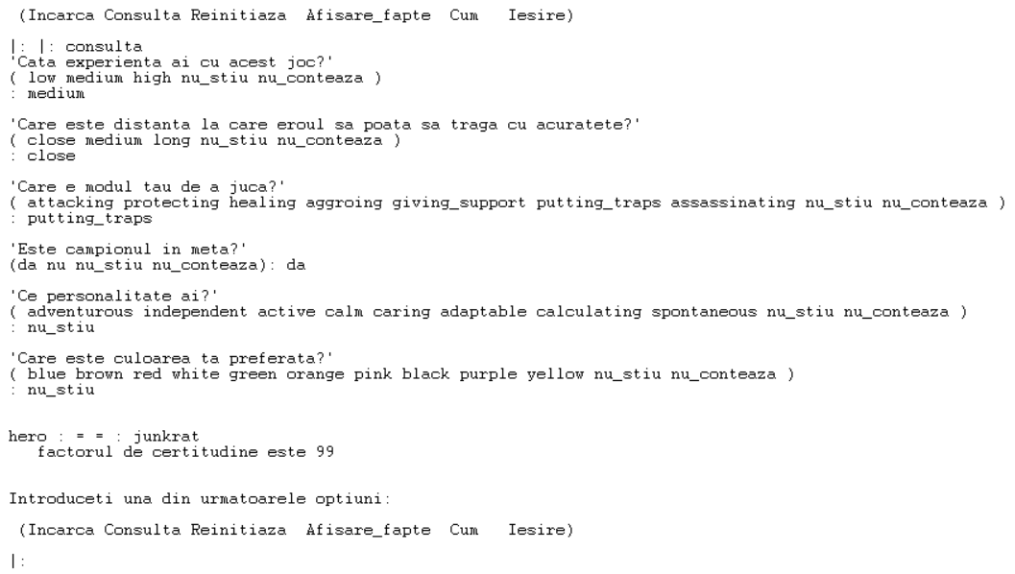

-reinitiaza. Instructiune folosita pentru resetarea faptelor si a solutiei aflate anterior prin intermediul instructiunii ‘consulta’ pentru a putea realiza o noua consultare.

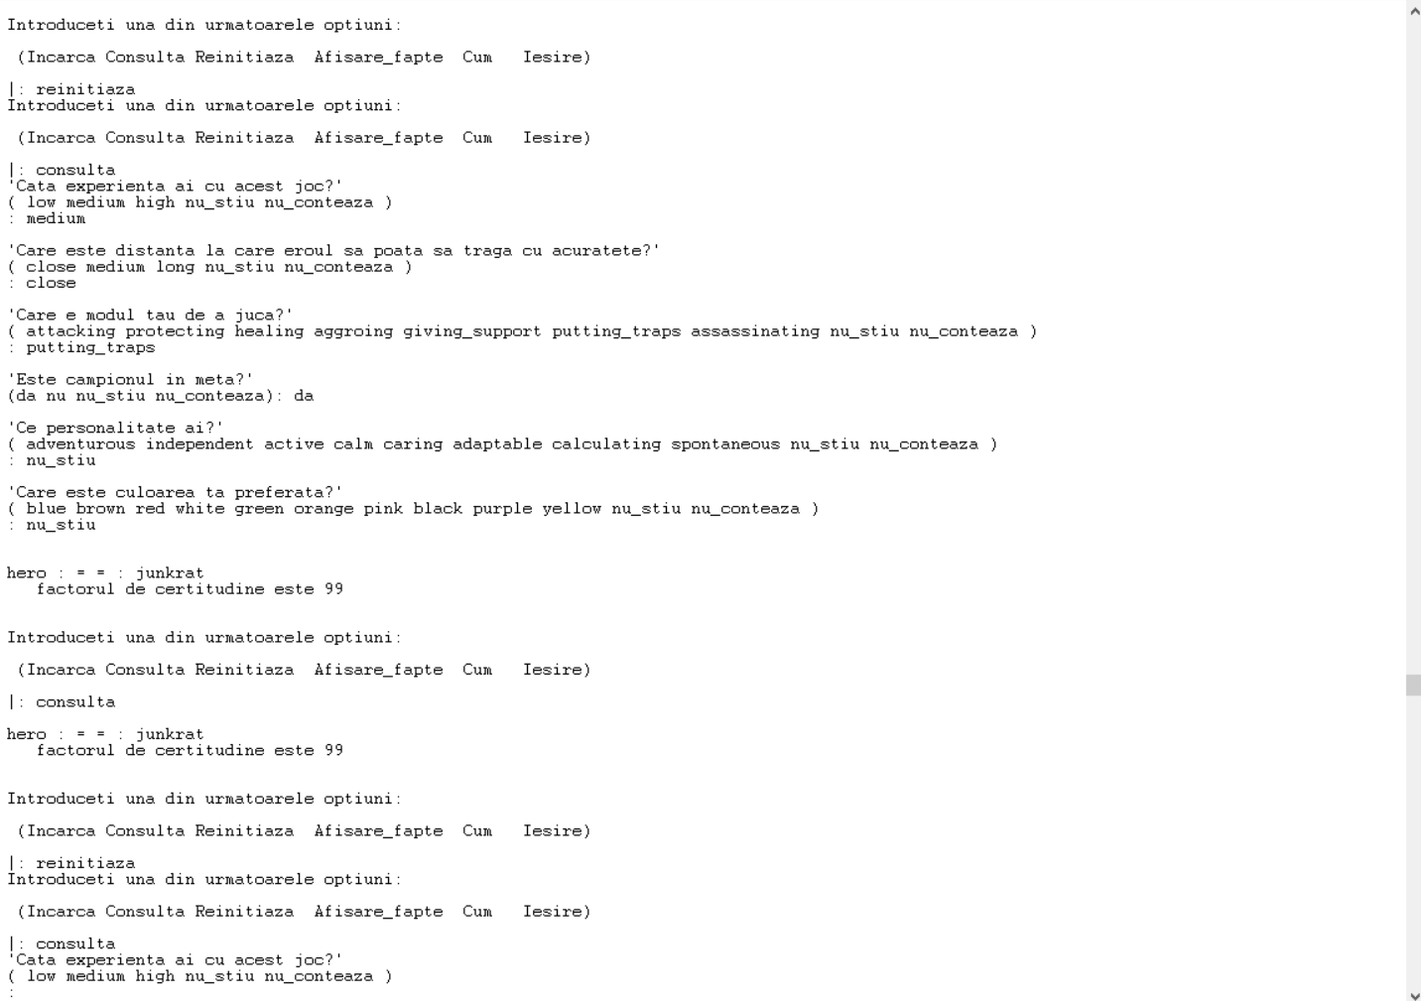

-afisare_fapte. Instructiune folosita pentru a afisa atributele si valorile folosite pentru a ajunge la solutia anterioara.

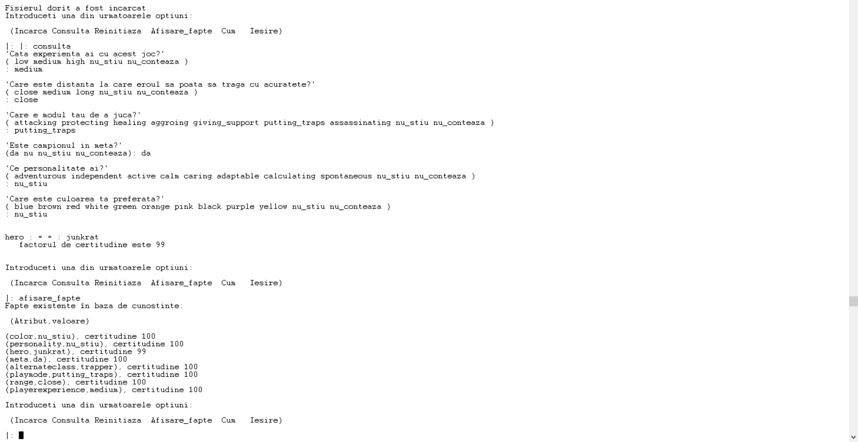

-cum. Instructiune folosita pentru a afisa regulile folosite pentru a ajunge la solutia derivata anterior,si daca atributele au fost date de utilizator sau nu.

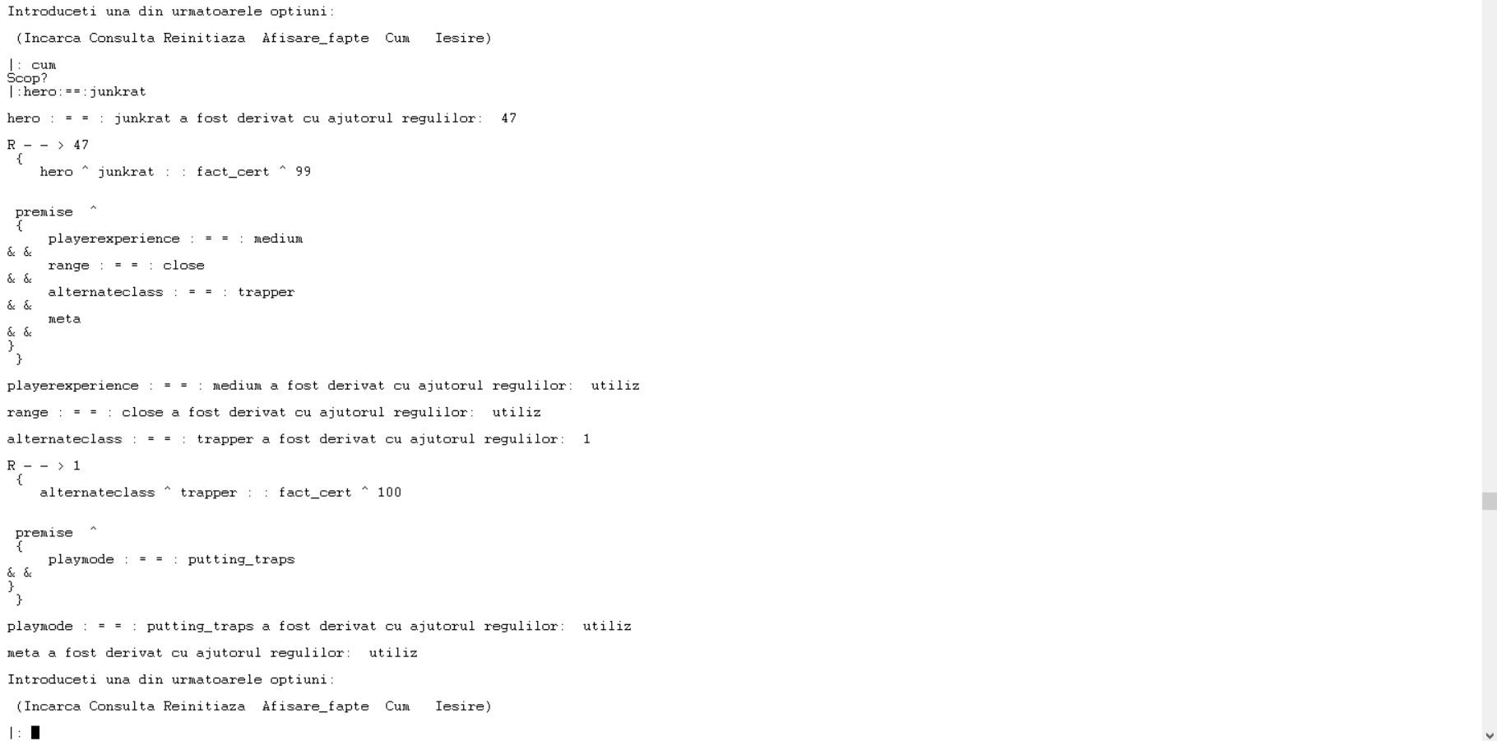

4.Cazuri

d. **In cazul intrebarilor cu raspuns boolean trebuie sa se afiseze si optiunile da/nu.**



e. **De asemenea sa existe un caz in care sistemul expert nu da solutii.**

**si**

f. **Daca sistemul nu da solutii, atunci se va afisa pe ecran un mesaj in care se indica faptul ca nu exista solutii.**

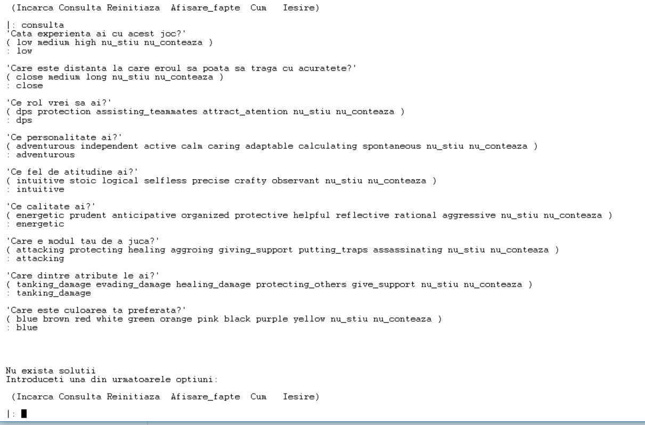

g. **Sa existe macar o secventa de raspunsuri la intrebari, prin care se obtine o singura solutie, si respectiv o secventa care duce la mai multe solutii posibile.**



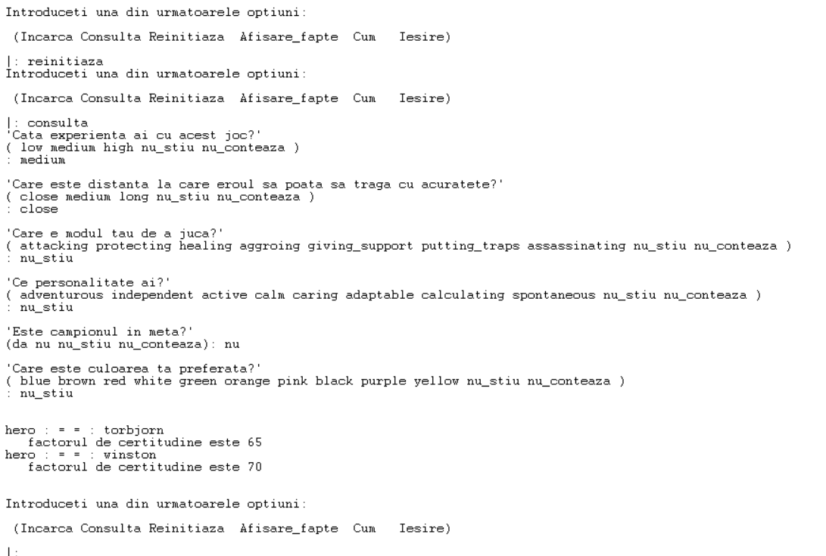

h. **Sa existe minim un atribut care este necesar doar pentru o parte din solutiile posibile. Aceste atribute vor fi evidentiate in documentatie.**

**Fie solutiile:**

R --> 40

{- hero ^ soldier76 :: fact_cert ^ 95

premise ^

{

playerexperience :==: low

&&range :==: medium

&&role:==: dps

&&meta

}

}.

R --> 41

{- hero ^ bastion :: fact_cert ^ 93

premise ^

{

playerexperience :==: low

&&range :==: medium

&&role :==: protection

&&meta

}

}.

R --> 42

{- hero ^ lucio :: fact_cert ^ 91

premise ^

{

playerexperience :==: low

&&range :==: close

&&role :==: assisting_teammates

&&meta

}

}.

R --> 43

{- hero ^ reinhardt :: fact_cert ^ 90

premise ^

{

playerexperience :==: low

&&range :==: medium

&&role :==: attract_atention

&&meta

}

}.

Pentru a ajunge la solutiile astea,este necesar atributule role,care este prezent in aceste solutii,dar nu si in restul solutiilor

**i.Sa existe minim o solutie cu mai multe cai posibile care sa duca la ea (de exemplu doua reguli care stabilesc valoarea atributului scop la acea solutie).**

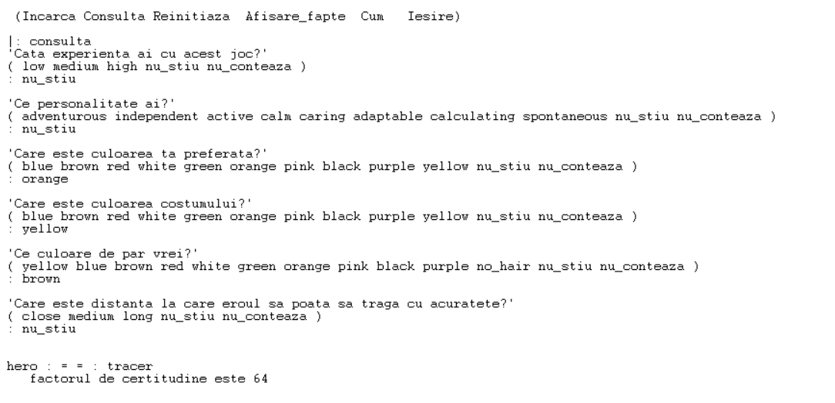

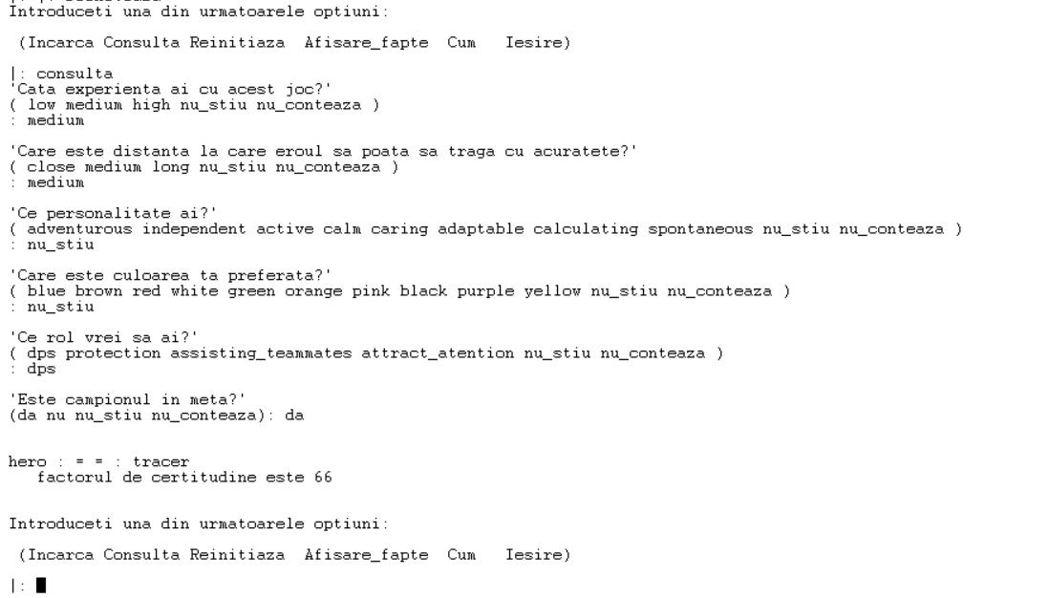

j. **Solutiile (in Prolog) se vor afisa in ordinea descrescatoare a factorului de certitudine.**

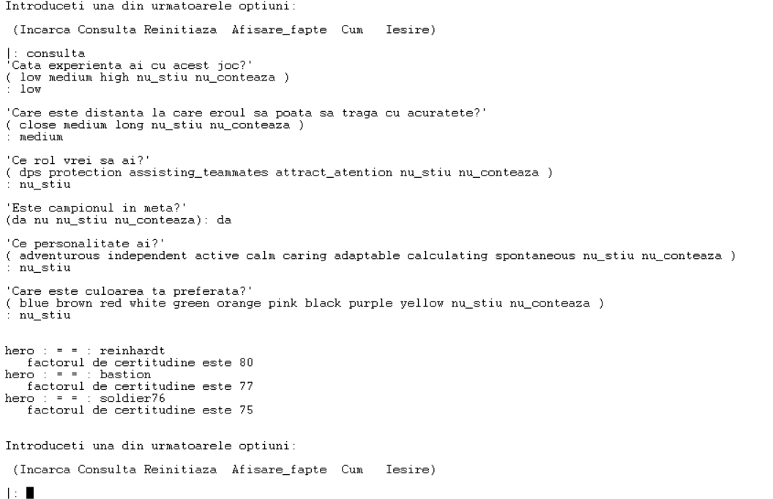

k. **Raspunsurile la intrebari permit existenta unui factor de certitudine**

R --> 7

{typeofplaying ^ protector :: fact_cert ^ 81

premise ^

{

personality :==: independent

&&attitude :==: stoic

&&quality :==: protective

}

}.

intrebare --> personality

text ^ 'Ce personalitate ai?'

opt{

adventurous,independent,active,calm,caring,adaptable,calculating,spontaneous

}.

intrebare --> attitude

text ^ 'Ce fel de atitudine ai?'

opt{

intuitive,stoic,logical,selfless,precise,crafty,observant

}.

intrebare --> quality

text ^ 'Ce calitate ai?'

opt{

energetic,prudent,anticipative,organized,protective,helpful,reflective,rational,aggressive

}.

l. **Este obligatoriu sa puteti afisa demonstratia pentru raspunsurile date.**



**m.Sistemul expert sa admita pentru unele intrebari si raspunsurile nu_stiu si nu_conteaza (se va specifica in cerintele individuale cum marcam aceste intrebari). Daca o intrebare primeste raspunsul cu valoarea nu_stiu, atunci sistemul expert va sari peste regulile care au nevoie de valoarea acelui atribut (pentru ca nu ne putem baza pe valoarea lui). Daca o intrebare primeste raspunsul cu valoarea nu_conteaza, atunci considera testul pentru atributul asociat ca fiind adevarat in orice regula indiferent de valoarea lui.**



5.Explicarea etapelor:

Etapa 1

- hero('Genji','Genji flings precise and deadly Shuriken at his targets, and uses his technologically-advanced katana to deflect projectiles or deliver a Swift Strike that cuts down enemies.').

- hero('McCree','Armed with his Peacekeeper revolver, McCree takes out targets with deadeye precision and dives out of danger with eagle-like speed.').

- hero('Pharah','Soaring through the air in her combat armor, and armed with a launcher that lays down high-explosive rockets, Pharah is a force to be reckoned with.').

- hero('Reaper','Hellfire Shotguns, the ghostly ability to become immune to damage, and the power to step between shadows make Reaper one of the deadliest beings on Earth.').

- hero('Soldier 76','Armed with cutting-edge weaponry, including an experimental pulse rifle that’s capable of firing spirals of high-powered Helix Rockets, Soldier: 76 has the speed and support know-how of a highly trained warrior.').

- hero('Sombra','Stealth and debilitating attacks make Sombra a powerful infiltrator. Her hacking can disrupt her enemies, ensuring they’re easier to take out, while her EMP provides the upper hand against multiple foes at once. Sombra’s ability to Translocate and camouflage herself makes her a hard target to pin down.').

- hero('Tracer','Toting twin pulse pistols, energy-based time bombs, and rapid-fire banter, Tracer is able to "blink" through space and rewind her personal timeline as she battles to right wrongs the world over.').

- hero('Bastion','Repair protocols and the ability to transform between stationary Assault, mobile Recon and devastating Tank configurations provide Bastion with a high probability of victory.').

- hero('Hanzo','Hanzo’s versatile arrows can reveal his enemies or fragment to strike multiple targets. He can scale walls to fire his bow from on high, or summon a titanic spirit dragon.').

- hero('Junkrat','Junkrat’s area-denying armaments include a Frag Launcher that lobs bouncing grenades, Concussion Mines that send enemies flying, and Steel Traps that stop foes dead in their tracks.').

- hero('Mei','Mei’s weather-altering devices slow opponents and protect locations. Her Endothermic Blaster unleashes damaging icicles and frost streams, and she can Cryo-Freeze herself to guard against counterattacks, or obstruct the opposing team’s movements with an Ice Wall.').

- hero('Torbjorn','Torbjörn’s extensive arsenal includes a rivet gun and hammer, as well as a personal forge that he can use to build upgradeable turrets and dole out protective armor packs.').

- hero('Widowmaker','Widowmaker equips herself with whatever it takes to eliminate her targets, including mines that dispense poisonous gas, a visor that grants her squad infra-sight, and a powerful sniper rifle that can fire in fully-automatic mode.').

- hero('D.Va','D.Va’s mech is nimble and powerful—its twin Fusion Cannons blast away with autofire at short range, and she can use its Boosters to barrel over enemies and obstacles, or deflect attacks with her projectile-dismantling Defense Matrix.').

- hero('Reinhardt','Clad in powered armor and swinging his hammer, Reinhardt leads a rocket-propelled charge across the battleground and defends his squadmates with a massive energy barrier.').

- hero('Roadhog','Roadhog uses his signature Chain Hook to pull his enemies close before shredding them with blasts from his Scrap Gun. He’s hardy enough to withstand tremendous damage, and can recover his health with a short breather.').

- hero('Winston','Winston wields impressive inventions—a jump pack, electricity-blasting Tesla Cannon, portable shield projector and more—with literal gorilla strength.').

- hero('Zarya','Deploying powerful personal barriers that convert incoming damage into energy for her massive Particle Cannon, Zarya is an invaluable asset on the front lines of any battle.').

- hero('Ana','Ana’s versatile arsenal allows her to affect - heroes all over the battlefield. Her Biotic Rifle rounds and Biotic Grenades heal allies and damage or impair enemies; her sidearm tranquilizes key targets, and Nano Boost gives one of her comrades a considerable increase in power.').

- hero('Lucio','On the battlefield, Lúcio’s cutting-edge Sonic Amplifier buffets enemies with projectiles and knocks foes back with blasts of sound. His songs can both heal his team or boost their movement speed, and he can switch between tracks on the fly.').

- hero('Mercy','Mercy’s Valkyrie Suit helps keep her close to teammates like a guardian angel; healing, resurrecting or strengthening them with the beams emanating from her Caduceus Staff.').

- hero('Symmetra','Symmetra utilizes her light-bending Photon Projector to dispatch adversaries, shield her associates, construct teleportation pads and deploy particle-blasting Sentry Turrets.').

- hero('Zenyatta','Zenyatta calls upon orbs of harmony and discord to heal his teammates and weaken his opponents, all while pursuing a transcendent state of immunity to damage.').

Scopul acestui proiect se numeste hero si este eroul pe care il va alege utilizatorul prin intermediul valorilor date de catre el in sistemul expert.

Etapa 2:

Atributul scop:Hero

Range:Close,Medium,Long

Class:Offensive,Defensive,Tank,Support

TypeOfPlaying:DamageDealer,Protector,Team_Helper,DamageAbsorber

Personality:Adventurous,Independent,Active,Calm,Caring,Adaptable,Calculating,Spontaneous

Attitude:Intuitive,Stoic,Logical,Selfless,Precise,Crafty,Observant

Quality:energetic,prudent,anticipative,organized,protective,helpful,reflective,rational,anticipative,prudent,logical

Meta:Yes,No

AlternateClass:Sniper,Trapper,

PlayMode:Attacking,Aggroing,Healing,Protecting,Assisting,PuttingTraps,Assassinating,

PlayExperience:Low,Medium,Hard

WayToPlay:Attack,Defense,Backer,Human_Shield

Role:DPS,Protection,AssistingPlayers,AttractAtention

Attribute:TankingDamage,EvadingDamage,HealingDamage,ProtectingOthers,GiveSupport

Negative:impatient,ruthless,rude,unpredictable,harsh,naughty,gullible,sneaky,overcritical,cynical

Personality-Defect:emotional,extremely-calculated

Color:blue,yellow, brown, red, white, green, orange, pink, black, purple

Costume: blue,brown,red,white,green,orange,pink,black,purple,yellow

Hair: yellow,blue,brown,red,white,green,orange,pink,black,purple,no_hair

Atribute de la utilizator:

PlayExperience,Range,Role,Meta,PlayMode,Personality,Attitude,Quality,Attribute,Negative,Color

Atribute deduse:

AlternateClass <- PlayMode

WayToPlay <- TypeOfPlaying <- Personality,Attitude,Quality

Class <- PlayMode,Attribute

Personality-Defect <- Negative

Arborii in care atributele sunt introduse de catre utilizator:

Hero:Soldier76

Meta:Yes

Range:Medium

Role:DPS

PlayExperience:

Low

Meta:Yes

Hero:Bastion

Meta:Yes

Range:Medium

Role:

Protection

PlayExperience:

Low

Arborii de inaltime=2.

Hero: Junkrat

Range:Close

AlternateClass:

Trapper

PlayExperience:Medium

Meta:Yes

PlayMode:

PuttingTraps

Hero:Widowmaker

Range:Long

AlternateClass:

Sniper

PlayExperience:Medium

Meta:No

PlayMode:

Assassinating

Arborii de inaltime=3.

Hero: Tracer

Color:yellow

Class:Offensive

WayToPlay:Attack

PlayExperience:Medium

Meta:Yes

Range:Medium

Personality: adventurous

Attitude: intuitive

Quality: energetic

Personality-Defect:Emotional

Negative:impatient

PlayMode:Attacking

Attribute: EvadingDamage

TypeOfPlaying:DamageDealer

Hero:Roadhog

Color: pink

Negative: Rude

Personality-Defect:Emotional

Range:Close

Class:Tank

WayToPlay:Attack

PlayExperience:Medium

Meta:Yes

Personality: active

Attitude: intuitive

Quality: anticipative

Attribute: TankingDamage

PlayMode:Aggroing

TypeOfPlaying:DamageDealer

Etapa 3:

Formatul folosit:

regulile vor avea :

R --> id (unde id este numarul regulii)

{atribut_concluzie ^ valoare :: fact_cert ^ nr (concluzia; nr este factorul de certitudine)

premise ^ (conditiile intre acolade, atributele separate cu &&)

{

atr :==: valoare (pentru atribute cu valori multiple)

&& atr (pentru atribute booleene, valoare true)

&& \\ atr (pentru atribute booleene, valoare false)

}

}.

intrebarile vor avea formatul:

intrebare --> atribut

text ^ 'continut intrebare'

opt {

val1 | val2 | val3

}.

scopul se va defini:

scop ^ atr.

Solutiile scop:

Genji,McCree,Pharah,Reaper,Soldier76,Sombra,Tracer,Bastion,Hanzo,

Junkrat,Mei,Torbjorn,Widowmaker,D.Va,Reinhardt,Roadhog,Winston,

Zarya,Ana,Lucio,Mercy,Symmetra,Zenyatta

Atribute cu valori multiple:Waytoplay,Class,Role

Atribut boolean:meta

Exemplu de regula/intrebare:

intrebare --> personality

text ^ 'Ce personalitate ai?'

opt{

adventurous | independent | active | calm | caring | adaptable | calculating | spontaneous

}.

intrebare --> attitude

text ^ 'Ce fel de atitudine ai?'

opt{

intuitive | stoic | logical | selfless | precise | crafty | observant

}.

intrebare --> quality

text ^ 'Ce calitate ai?'

opt{

energetic | prudent | anticipative | organized | protective | helpful | reflective | rational | aggressive

}.

R --> 7

{typeofplaying ^ protector :: fact_cert ^ 81

premise ^

{

personality :==: independent

&&attitude :==: stoic

&&quality :==: protective

}

}.

R --> 21

{waytoplay ^ defense :: fact_cert ^ 100

premise ^

{

typeofplaying :==: protector

}

}.

In acest caz,avem o inlantuire inainte,inlantuirea realizandu-se astfel:

WayToPlay <- TypeOfPlaying <- Personality,Attitude,Quality

6.Cerinte individuale:

f. In folder-ul ‘output_overwatch’ veti crea cate un fisier numit demonstratie_solutie_pt_erou[fc].txt pentru fiecare solutie in parte. Cuvantul *erou* din numele fisierului va fi inlocuit cu valoarea solutiei, iar *fc* cu factorul de certitudine. Fisierul va contine, evident, demonstratia pentru acea solutie. In demonstratii, afisarea regulilor se va face exact in forma in care au fost scrise in fisierul de intrare.:

R --> id (unde id este numarul regulii)

{atribut_concluzie ^ valoare :: fact_cert ^ nr (concluzia; nr este factorul de certitudine)

premise ^ (conditiile intre acolade, atributele separate cu &&)

{

atr :==: valoare (pentru atribute cu valori multiple)

&& atr (pentru atribute booleene, valoare true)

&& \\ atr (pentru atribute booleene, valoare false)

}

}.

Forma de afisare a celorlalte tipuri de informatii din demonstratie se lasa la alegerea studentilor.

Pentru realizarea acestui subpunct,verificam daca avem sau nu folder-ul ‘output_overwatch’.Daca nu il avem,programul il creeaza.Dupa ce am aflat solutia,facem ca numele fisierului sa contina valoarea solutiei si factorul de certitudine.Dupa care,introducem in fisier datele provenite la rularea instructiunii

‘cum’.

Sfarsit